**RNAO_Logo_H_CMYK.tif**

**Gap Analysis Worksheet:**

***Pain: Prevention, Assessment and Management,* Fourth Edition**

**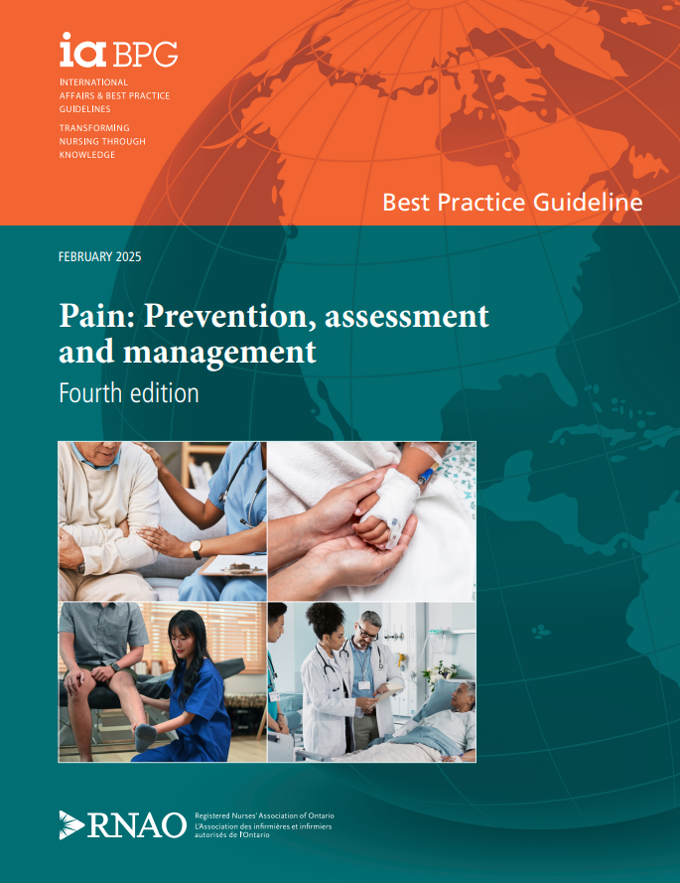**

This guideline can be downloaded for free at:

[Assessment and Management of Pain | RNAO.ca](https://rnao.ca/bpg/guidelines/assessment-and-management-pain)

The Leading Change Toolkit (Fourth Edition) is also available at:

[The Leading Change Toolkit (Fourth edition) | RNAO.ca](https://rnao.ca/bpg/leading-change-toolkit)

**What is a Gap Analysis?**

A process comparing your organization’s current practice with evidence-based best practice recommendations to determine:

* Existing practices and processes that are currently implemented and supported by best practices. This information is useful to reinforce practice strengths.
* Recommendations that are currently partially implemented in practice. These would be good first targets for change efforts.
* Recommendations that are not currently being met.
* Recommendations that are not applicable to your practice setting.

**Uses of a Gap Analysis**

* Contributes to annual evaluation by allowing you to compare practice from year to year and choose which areas to focus on changing within the year.
* Focuses on needed practice change which prevents a total overhaul of practice and builds on established practices and processes.
* Informs next steps such as development of infrastructure to support implementation, partnership engagement, identification of barriers and facilitators, resource requirements, selection of implementation strategies and evaluation approaches.
* Leads to sustained practice change by informing plans related to process, staff and organization and reinforces current evidence-based pract

**Conducting a Gap Analysis**

Engage the team, and internal and external individuals and teams as needed in gathering information

for the gap analysis.

Collect information on:

* Current practice – is it known and is it consistent? (met, unmet, partially met)
* Partially met recommendations may only be implemented in some parts of the home, or you may feel it is only half done.
* Are there some recommendations that must be implemented before others?
* Can any recommendations be implemented quickly? These are easy wins and build confidence in the change.
* Are there any barriers to implementation? These may include staffing, skill mix, budget, workload issues, etc.
* What are the time frames in relation to specific actions and people or departments who can support the change effort?
* Are there links with other practices and programs in the organization?
* Are there existing resources and education that your organization can access?
* Are there any must-do recommendations that are crucial to resident and staff safety?

**Next Steps**

1. Celebrate the recommendations you are meeting.
2. Prioritize the areas you want to work on. Start with practice changes that can be made easily or are crucial to resident and staff safety. Start by reinforcing success and focusing on quick wins.
3. These priority areas become the foundation for planning your program or implementing practice change.
4. For more information on taking your gap analysis to the next level see [The Leading Change Toolkit (Fourth edition) | RNAO.ca](https://rnao.ca/bpg/leading-change-toolkit)

**Long-Term Care Homes:**

Contact your Long-Term Care Implementation Coach to assist you in completing a gap analysis. Visit [**RNAO.ca/ltc**](http://www.rnao.ca/ltc).

**](http://ltctoolkit.rnao.ca)What does certainty of evidence and strength of recommendation mean?**

**Certainty/confidence of evidence** (also known as quality of the evidence) is determined by a very rigorous quality appraisal of studies found through a systematic review. Certainty/confidence of evidence can be high (very good quality), moderate, low or very low (very poor quality).

**Strength of recommendation** reflects the certainty of evidence as well as other factors such as the balance of benefits and harms, values and preferences and health equity considerations. A recommendation can either be strong or conditional.

**For more information**, please refer to the “Overview of methodology: Good practice statements and recommendations” and “Interpretation of evidence

and recommendation statements” in this best practice guideline.

|  |  |  |  |  |
| --- | --- | --- | --- | --- |
| Date Completed: | |  | | |
|  | | | | |
| Team Members participating in the Gap Analysis: | | | | |
|  | |  |  |
|  | |  |  |
|  | |  |  |

Completion of this gap analysis allows for the annual comparison of your current practice to evidence-based practices as regulated by the MOHLTC per Fixing Long-Term Care Act, 2021

at  <https://www.ontario.ca/laws/statute/21f39> & [O. Reg. 246/22: GENERAL (ontario.ca)](https://www.ontario.ca/laws/regulation/r22246).

| **RNAO Clinical Best Practice Guideline Good Practice Statements and Recommendations** | Met | Partially Met | Unmet | Notes  (Examples of what to include: is this a priority to our home, information on current practice, possible overlap with other programs or partners) |
| --- | --- | --- | --- | --- |
| **Screening and assessment** | | | | |
| **Good practice statement 1.0:**  It is good practice for all health providers to conduct initial and ongoing screening and assessment for pain with people in their care. Pain assessment includes a comprehensive, evidence-based assessment using a person- and family-centred care approach.  Strength of the recommendation: Not applicable |  |  |  |  |
| **Management** | | | | |
| **Good practice statement 2.0:**  It is good practice to provide an integrative approach to pain prevention, assessment and management. An integrative approach (i.e., non-pharmacological and/or pharmacological strategies) includes individualized, person- and family-centred care.  Strength of the recommendation: Not applicable |  |  |  |  |
| **Interprofessional practice** | | | | |
| **Good practice statement 3.0:**  It is good practice for health service organizations and health systems to implement an interprofessional practice approach to pain prevention, assessment, and management.  Strength of the recommendation: Not applicable |  |  |  |  |
| **Recommendation question #1**:Should organizational or health system implementation of a specialized interprofessional pain care team be recommended or not? | | | | |
| **Recommendation 1.0:**  The expert panel suggests that health service  organizations provide access to a specialized  interprofessional pain care team for the prevention,  assessment and management of pain for people  experiencing acute or chronic pain.  Strength of the recommendation: Conditional |  |  |  |  |
| **Recommendation question #1**:Should organizational or health system implementation of a specialized interprofessional pain care team be recommended or not? | | | | |
| **Education** | | | | |
| **Good practice statement 4.0:**  It is good practice for academic institutions to provide comprehensive education for students entering health professions on pain prevention, assessment, and management.  Strength of the recommendation: Not applicable |  |  |  |  |
| **Recommendation question #2**: Should interactive education on pain assessment, prevention and management strategies for students entering health professions be recommended or not? | | | | |
| **Recommendation 2.0:**  The expert panel suggests that academic institutions implement interactive education for all students entering health professions on pain prevention, assessment, and management.  Strength of the recommendation: Conditional |  |  |  |  |
| **Good practice statement 5.0:**  It is good practice for health service organizations to provide interprofessional and discipline-specific education for all health providers on comprehensive pain prevention, assessment, and management.  Strength of the recommendation: Not applicable |  |  |  |  |
| **Recommendation question #3**: Should interactive education on pain assessment, prevention and management for health providers be recommended or not? | | | | |
| **Recommendation 3.0:**  The expert panel suggests that health service organizations implement opportunities for interactive education for all health providers on pain prevention, assessment, and management.  Strength of the recommendation: Conditional |  |  |  |  |